Geometry: Unit 11, Lesson 1
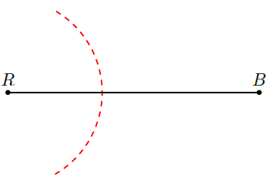
- Natalie is constructing the perpendicular bisector of $\overline{RB}$. Her partial construction is shown. What is the error she made in the first step of her construction?

She didn’t open her compass width wide enough.

- What is the circumcenter of a triangle?

It is the point of concurrency between the perpendicular bisectors of the sides of a triangle.

- What is a segment with both endpoints lying on the circumference of a circle that passes through the center of the circle?

Diameter

